**COMPUTER NETWORKS - CSA07**

**Parthibhan .R**

**192224275**

**EXPRIMENT 15:-**

Make Computer Lab in Cisco Packet Tracer

Github Link:- <https://github.com/parthibhan007/CSA0748-computer-network/tree/main/expriment%2015>

Simulation:-

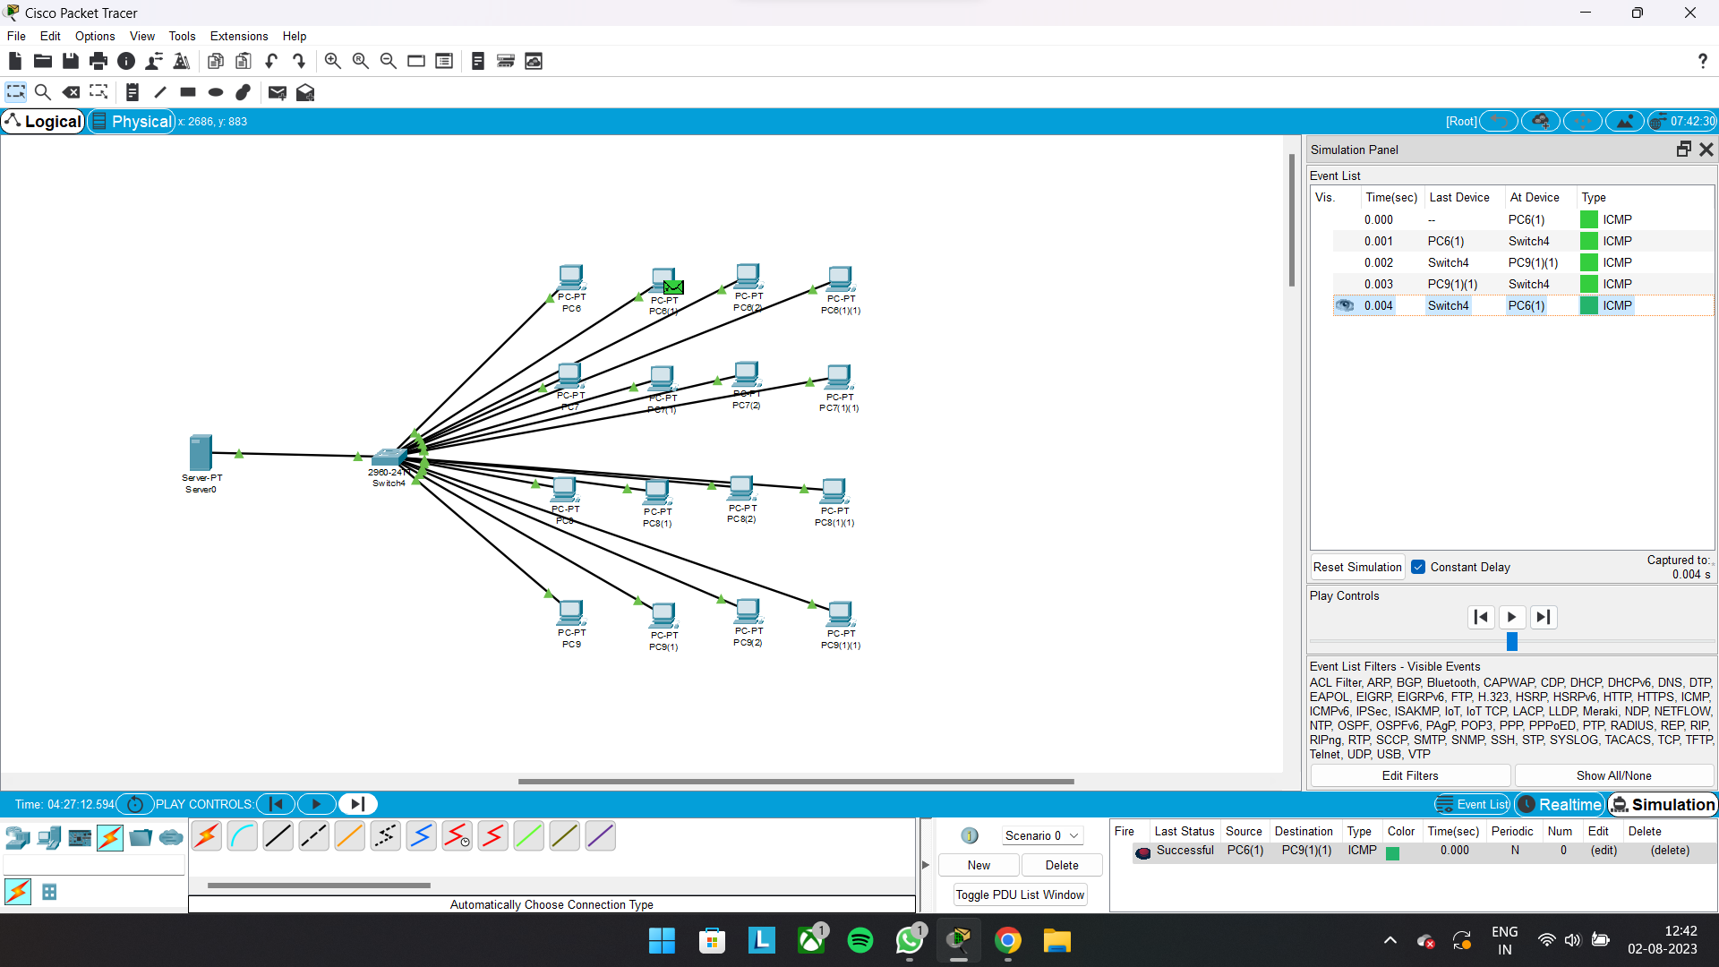

Real Time:-

